|  |  |  |  |
| --- | --- | --- | --- |
| **Course Name:** | **Linear Integrated Circuits and Design** | **Semester:** | **V** |
| **Date of Performance:** |  | **Batch No:** | **B1** |
| **Faculty Name:** | **Prof. Milind Marathe** | **Roll No:** | **1912052** |
| **Faculty Sign & Date:** |  | **Grade/Marks:** | **/25** |

Experiment No: 11

Title:To develop the Circuits using anyone ICs from the given ICs: IC78XX,IC79XX, IC555,IC317,IC337,IC723,IC565



**COs to be achieved:**

**CO3:** Design circuits using IC555

|  |  |  |
| --- | --- | --- |
| **Aim and Objective of the Experiment:** | | |
| * To dc motor speed control | using using IC555 |  |

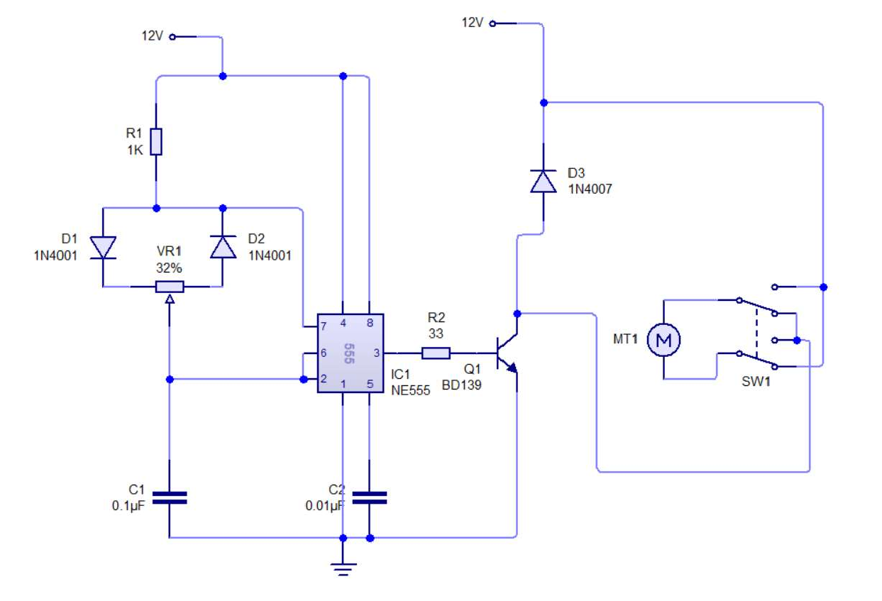

dc motor speed control using using IC555

**Circuit Diagram:**

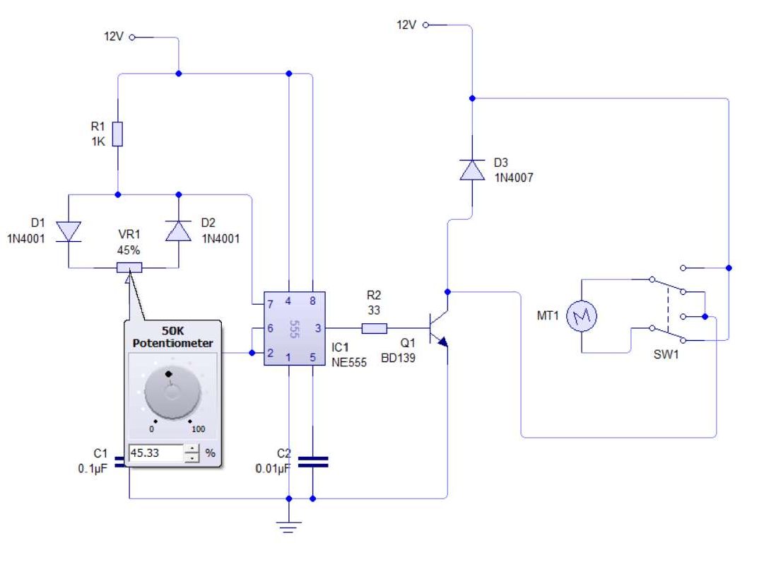

**Output waveforms:**

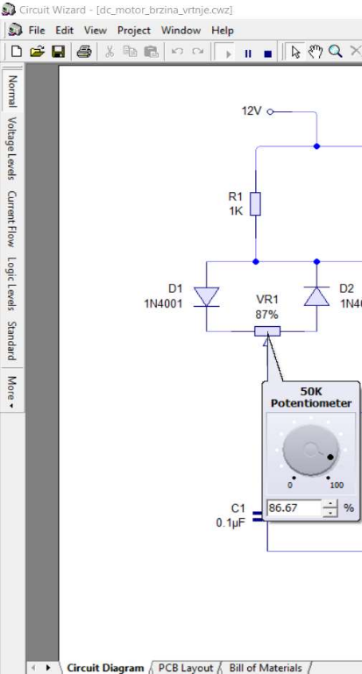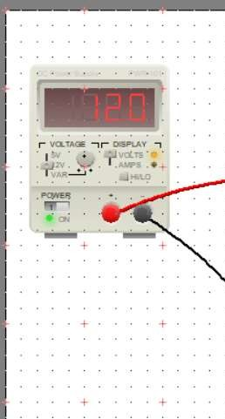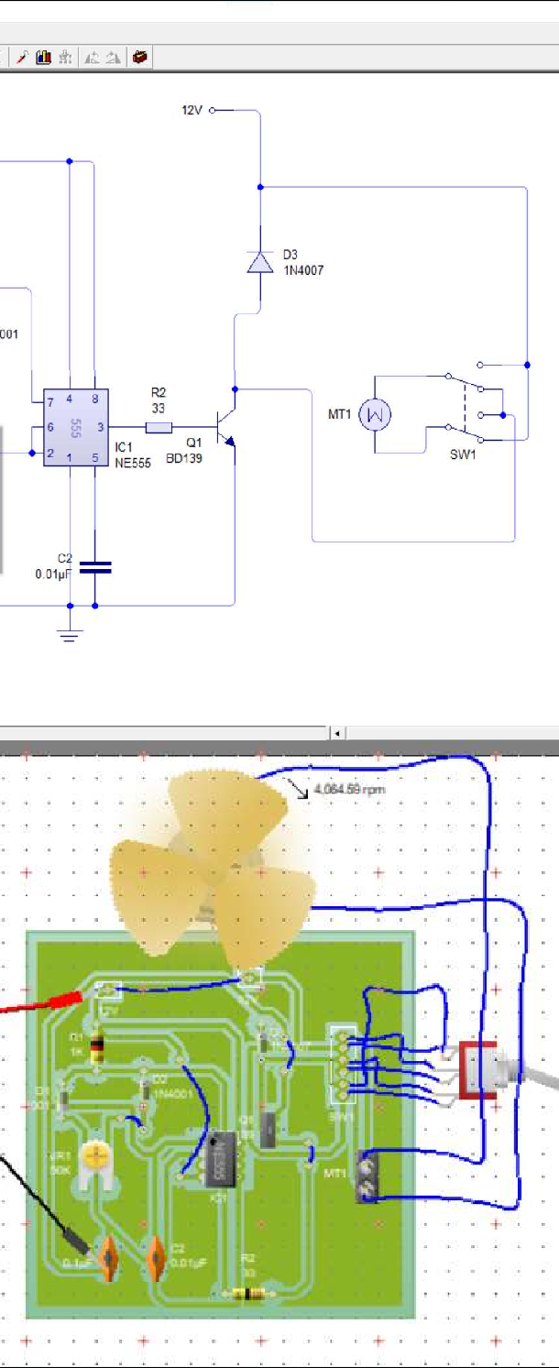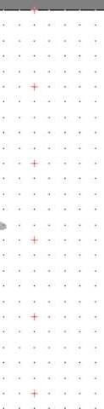

Signature of faculty in-charge with Date:

When the duty cycle of the PWM signal is high then the speed of the motor will be high and vice versa.The V indicates the voltage required for the motor and it should be selected based on the motor you are about to control with the IC.

**Conclusion:**